CAN-DO RESEARCH LAB | KNUST DEPARTMENT OF COMPUTER SCIENCE
PHASE 1 · STEP 1.2 — TESTBED SUBMISSION
ML RESULTS AND ANALYSIS SECTION — DRAFT 0 TEMPLATE

Part 0 — Passport Check Block
Field | Entry | Field | Entry
Student name | Bartimeus Manuel Nii Osabu; Oti Wisdom Boakye; Antwi Jeffrey Twum; Manu Richeal Pokuah; Karikari David Kweku (Group 3) | Student ID | 3382422; 3419922; 3372922; 3398922; 3394522
Supervisor | Dr. Eric Opoku Osei | Submission round | R1
Folder | ML | Date submitted | 7 August 2026
Model status | ENGINEERED (predictive learner applied as published) | F/M/R/S operation | F — Fabricate (SHAPtoSMS)
Dataset strategy | TRAINING-ONLY-AUG | Claim tier ceiling | Tier 1
Primary metric | AUC-PR (RPS@1/@2 for SHAPtoSMS) | Statistical test | McNemar exact + paired bootstrap 95% CI; BH FDR
Runs x folds | 5 runs (seeds) x 5 folds (CV diagnostic) | Random seed(s) | 42, 123, 777, 2024, 9999
Target journal (primary) | Computers & Education: Artificial Intelligence | Format family | Elsevier
Word budget (Results) | 1,200-2,200 (Elsevier) | Citation style | APA (7th ed.)
Methods Passport signed | YES | Methods round | R1

3. Results and Analysis
This section reports measured quantities only. Interpretation, comparison with prior literature, and causal accounts are deferred to the Discussion.

R1. Evaluation Corpus and Partition Summary
The held-out evaluation partition comprised 248 real student-year records, of which 241 were non-dropout and 7 were dropout, a positive rate of 2.82% (7/248). The partition was the temporal hold-out defined in Methods M9: all records with academic_year ≥ 2025 formed the test set, and it comprised 100% real data with no synthetic or resampled instances, verified by a per-run assertion of zero synthetic rows. Trainable models were evaluated across five independent seeds {42, 123, 777, 2024, 9999}, and a separate stratified five-fold cross-validation on the train+validation pool was run as a stability diagnostic, matching Methods M14 (five runs × five folds). The train+validation pool held 530 records (180 real + 350 synthetic; 62 positive, 11.7%, a 7.55:1 negative-to-positive ratio); the synthetic supplement was confined to that pool and served an augmentation-only role, while the evaluation partition was entirely real. All figures in this section trace to the single locked run described in Methods M21, in which the synthetic supplement is generated under a fixed seed and committed as a data artefact rather than regenerated at run time; the number reconciliation is given in R11. The evaluation protocol follows the TRAINING-ONLY AUGMENTATION design declared in Methods M10, and all reported claims are constrained to the Tier 1 ceiling.

R2. Baseline versus Proposed Performance — Main Results
Table 3 reports held-out test-set performance as mean ± standard deviation across the five seeds; the primary metric is AUC-PR, named as primary in Methods M15. The proposed XGBoost recorded AUC-PR 0.1167 ± 0.0444, an absolute delta of -0.0302 against the default XGBoost (0.1469 ± 0.0896). Among all comparators TabTransformer recorded the highest AUC-PR (0.2387 ± 0.0559) and the Attendance ranker the next highest (0.1284), both exceeding the proposed model on the primary metric; the Decision Tree recorded 0.0774 ± 0.0205. On recall, the proposed model recorded 0.4000 ± 0.1069, which is the higher of the two XGBoost variants (default: 0.3714 ± 0.1143); TabTransformer recorded higher recall still (0.5143 ± 0.0700), and the binary Attendance rule the highest of all (0.7143 at its single operating point). The earlier claim that the proposed model recorded the highest recall of the probabilistic models trained across seeds is withdrawn: it contradicted the table it accompanied. The paired bootstrap 95% confidence interval on the AUC-PR difference between the proposed and default models (10,000 resamples; the method declared in Methods M16) was [-0.0409, 0.1227], with a mean delta of 0.0170. Figure 4 plots the ROC and precision–recall operating characteristics for the four probabilistic models on the same axes.
Table 3. Held-out test-set performance (248 real records, 7 dropout), mean ± SD across five seeds. AUC-PR is the primary metric; the Δ column is the absolute difference in AUC-PR from the default XGBoost. The status-quo attendance baseline is reported as two rows because it requires two different score vectors (Methods M11): the deployed binary rule and a univariate continuous ranker. † Single seed-42 run (no ± SD), reported for completeness; calibration did not improve the primary metric (R10). ‡ The binary rule yields one operating point, so its AUC-ROC and AUC-PR are SINGLE-POINT values computed from that point (flagged 56/248; TP 5, FP 51, FPR 0.2116), not threshold-free areas. § The continuous ranker scores 1 − scaled(attendance_rate); threshold-dependent metrics are not defined for it, as it prescribes no decision rule. ¶ Seed-42 single-run reference for the proposed model: AUC-PR 0.1033, AUC-ROC 0.5969 — the anchor against which the isotonic row is compared, so that comparison sits in a single reference frame.
Model | AUC-PR (primary) | Δ AUC-PR vs default | AUC-ROC | F2 | Macro-F1 | Precision | Recall
Proposed XGBoost ¶ | 0.1167 ± 0.0444 | -0.0302 | 0.6182 ± 0.0754 | 0.1532 ± 0.0662 | 0.4478 ± 0.0675 | 0.0492 ± 0.0322 | 0.4000 ± 0.1069
Proposed XGBoost — isotonic-calibrated † | 0.0933 | -0.0100 (vs seed-42 uncalibrated ¶) | 0.6165 | 0.1220 | 0.4673 | 0.0370 | 0.2857
Default XGBoost | 0.1469 ± 0.0896 | 0.0000 | 0.6816 ± 0.0422 | 0.1747 ± 0.0422 | 0.4947 ± 0.0241 | 0.0586 ± 0.0173 | 0.3714 ± 0.1143
TabTransformer | 0.2387 ± 0.0559 | +0.0918 | 0.7248 ± 0.0409 | 0.2572 ± 0.0527 | 0.5254 ± 0.0383 | 0.0901 ± 0.0300 | 0.5143 ± 0.0700
Decision Tree | 0.0774 ± 0.0205 | -0.0695 | 0.5914 ± 0.0448 | 0.1869 ± 0.0560 | 0.5186 ± 0.0402 | 0.0763 ± 0.0309 | 0.3143 ± 0.0571
Attendance rule (binary, threshold 0.70) ‡ | 0.0718 (single point) | not comparable ‡ | 0.7513 (single point) | 0.2976 | 0.5182 | 0.0893 | 0.7143
Attendance ranker (continuous, univariate) § | 0.1284 | -0.0185 | 0.8678 | n/a | n/a | n/a | n/a
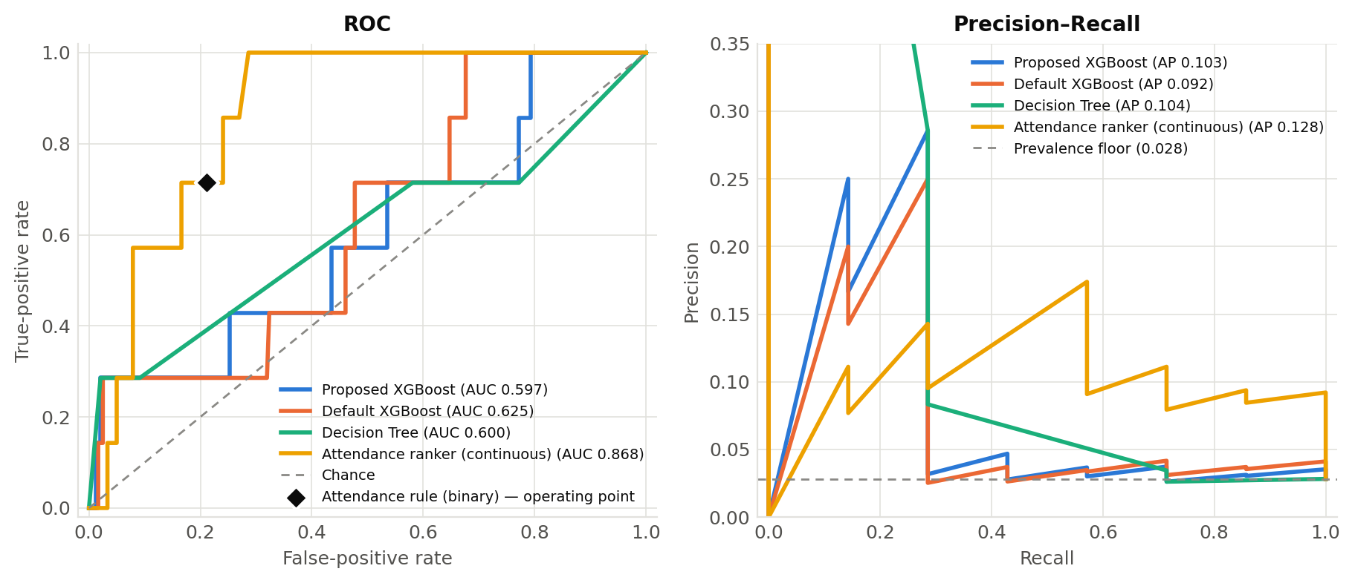
Figure 4. ROC curves (left) and precision–recall curves (right) for the proposed XGBoost, default XGBoost, Decision Tree and the continuous Attendance ranker on the held-out test set (seed 42); legend values are AUC-ROC and average precision. The binary Attendance rule is a single operating point, marked as a diamond on the ROC axes, and cannot be drawn as a curve. TabTransformer is reported in Table 3.

R3. Stability and Variance Across Runs and Folds
Five-fold stratified cross-validation on the train+validation pool returned per-fold AUC-PR of {0.252, 0.133, 0.329, 0.123, 0.235} for the proposed model (mean 0.214, SD 0.077) and {0.247, 0.168, 0.382, 0.120, 0.220} for the default model (mean 0.228, SD 0.089). For the proposed model the widest fold result was 0.329 and the narrowest was 0.123. Because AUC-PR is bounded below by class prevalence and the two partitions differ in prevalence (11.7% positive in the cross-validation pool against 2.82% in the test set), the two figures are not directly comparable as levels: on a lift-over-prevalence basis the cross-validation AUC-PR is 1.8× its floor and the held-out test AUC-PR is 4.1× its floor. Figure 5 shows the per-fold distribution for both models with individual fold points, the mean marked, and the same colour and line style used for each model throughout the section.
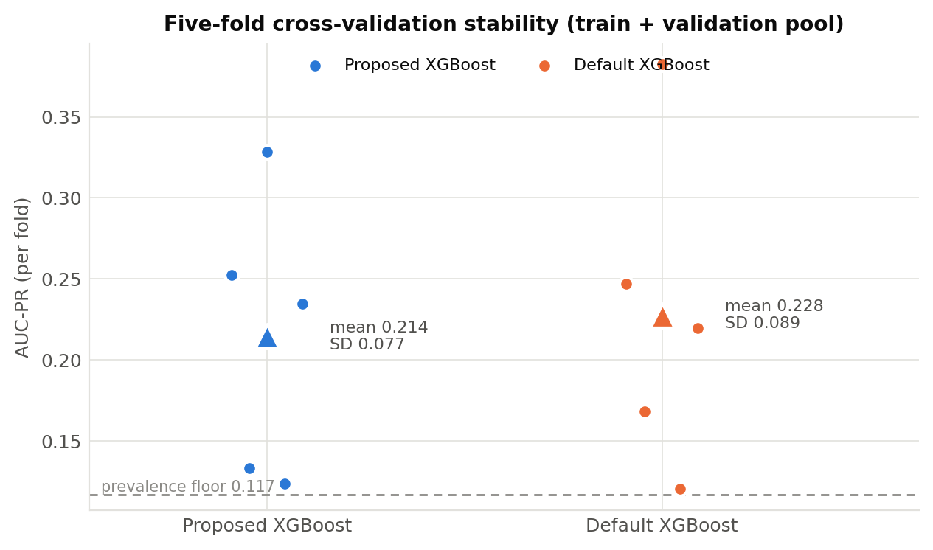
Figure 5. Five-fold cross-validation AUC-PR stability (train+validation pool) for the proposed and default XGBoost models. Points are individual folds; the triangle marks the mean (proposed 0.214 ± 0.077; default 0.228 ± 0.089).

R4. Statistical Comparison
McNemar’s exact test for correlated proportions (Methods M16) was applied to the seed-42 predictions of the proposed XGBoost against each baseline, with the Benjamini–Hochberg false-discovery-rate correction across the four comparisons at α = 0.05 (Table 4). Against the Default XGBoost the test yielded p = 0.7428 (BH-adjusted p = 0.7428; Retain H₀), with discordant-pair counts b = 17 and c = 20. Against the Decision Tree the test yielded p < 0.0001 (BH-adjusted p < 0.0001; Reject H₀), with discordant-pair counts b = 5 and c = 40. Against the TabTransformer the test yielded p = 0.0226 (BH-adjusted p = 0.0451; Reject H₀), with discordant-pair counts b = 22 and c = 41. Against the Attendance rule (binary) the test yielded p = 0.4704 (BH-adjusted p = 0.6272; Retain H₀), with discordant-pair counts b = 31 and c = 38. The direction of each discordance is stated explicitly in Table 4 rather than left to be inferred from the counts, because a significance result reported in the neutral register of "H₀ rejected" can be misread as a win. In every comparison the discordance favours the comparator rather than the proposed model, and among the comparisons that reach significance after correction (Decision Tree, TabTransformer) the significant result therefore favours the comparator, not the proposed model. The paired bootstrap 95% confidence interval on the AUC-PR delta between the proposed and default models (10,000 resamples) was [-0.0409, 0.1227] with a mean delta of 0.0170, and thus spanned zero; the effect size for the proposed-versus-default recall difference was Cohen’s h = 0.0000 (recall 0.2857 versus 0.2857 at the seed-42 operating points). The assumptions were checked as outcomes: McNemar requires paired binary outcomes on the same test instances, which held for the identical held-out partition; the bootstrap requires resampling with replacement, applied over the 10,000 resamples. Where the McNemar and bootstrap outcomes disagree, both are reported without reconciliation, per Methods M16.
Table 4. McNemar’s exact test (proposed XGBoost versus each baseline), seed-42 predictions, with Benjamini–Hochberg correction across the four comparisons. b and c are the discordant-pair counts: b counts records the proposed model classifies correctly and the comparator does not, c the reverse. The Direction column states which model the discordance favours.
Comparison (proposed vs) | McNemar p | b | c | BH-adjusted p | Decision | Direction
Default XGBoost | 0.7428 | 17 | 20 | 0.7428 | Retain H₀ | Favours Default XGBoost
Decision Tree | < 0.0001 | 5 | 40 | < 0.0001 | Reject H₀ | Favours Decision Tree
TabTransformer | 0.0226 | 22 | 41 | 0.0451 | Reject H₀ | Favours TabTransformer
Attendance rule (binary) | 0.4704 | 31 | 38 | 0.6272 | Retain H₀ | Favours Attendance rule

R5. Contribution Isolation — Ablation or Comparative Evaluation
The engineered contribution (SHAPtoSMS) was isolated by the ablation declared in Methods M16, in which exactly one component — the ordering of packed features — was reverted from strict descending |φ| order to a fixed canonical order, holding candidate selection, lexicalisation, and the 160-character budget identical. The evaluation population is the proposed XGBoost’s own seed-42 flagged set: 57 of 248 records clear the proposed model’s seed-42 threshold (0.34), containing 2 of the 7 real dropout cases, and the gold ranking is taken from the same model whose attributions are packed. An earlier draft defined this population by a comparator model’s threshold while packing the proposed model’s attributions; that cross-model definition has been replaced, and the result on the earlier population is reported below as a sensitivity check. Two fidelity quantities are reported separately, following Methods M17. On rank preservation — whether the packed alert’s first k factors match the model’s own top-k |SHAP| ranking — the rank-preserving protocol recorded RPS@1 = 1.0000 and RPS@2 = 0.8596, while the naive fixed-order baseline recorded RPS@1 = 0.1930 and RPS@2 = 0.0351, an absolute ablation delta of +0.8070 at RPS@1 and +0.8245 at RPS@2 (Figure 8). On directional agreement — whether a top-k attribution carries a sign agreeing with the observed outcome — the rank-preserving protocol recorded DAS@1 = 0.7368 and DAS@2 = 0.9825 against 0.0877 and 0.0877 for the naive baseline. On the earlier cross-model population (40 records) the same ordering conclusion holds (RPS@1 1.0000 versus 0.1750; DAS@1 0.7250 versus 0.0750), so the ablation result is not an artefact of the population definition. The earlier reported ablation loss at RPS@1 is therefore withdrawn: it arose from scoring a cross-model population with a metric that measured directional agreement while being described as rank preservation. Every generated alert complied with the 160-character GSM single-segment limit, with lengths of 70–155 characters (mean ≈ 96) and 1–6 risk factors named per alert (mean 2.46); compliance is guaranteed by construction, so Table 5 verifies that the implemented packer honours its own budget rather than establishing an empirical delivery result (Objective 3, as narrowed). The supporting-system ablation compared the proposed against the default XGBoost, which differ only in the imbalance-handling layers: the absolute AUC-PR delta was -0.0302 (Table 3), and the paired bootstrap 95% confidence interval spanned zero (R4). Each imbalance layer was then isolated individually. Removing Layer 1 (SMOTE) entirely lowers AUC-PR from 0.1253 at sampling_strategy 0.40 and 0.1167 at the configured 0.20 to 0.0779, and raising the strategy to 0.50 gives 0.1343 with recall 0.4857, so Layer 1 is load-bearing at this pool composition and its configured setting is not optimal. Isolating Layer 2 against Layer 3 shows the opposite: at scale_pos_weight = 1 with F2 thresholding the model records AUC-PR 0.1302 and recall 0.4286, against 0.1167 and 0.4000 with both layers applied, so applying scale_pos_weight and an F2-optimised threshold together does not improve on the threshold alone and is consistent with double-counting the imbalance correction. The complementary configuration declared in Methods M16 — the full scale_pos_weight (7.49 at seed 42) with a fixed 0.5 threshold — recorded AUC-PR 0.1167 ± 0.0444, recall 0.3143 ± 0.0571, precision 0.0808 and F2 0.1973, completing the declared isolation; the fourth cell of the design, scale_pos_weight = 1 with a fixed 0.5 threshold, recorded AUC-PR 0.1302 ± 0.0363, recall 0.2286 ± 0.0700, precision 0.1360 and F2 0.2003. Read as a 2 × 2, the design separates the two layers cleanly. AUC-PR is threshold-free and therefore varies only with scale_pos_weight, and it is higher at scale_pos_weight = 1 in both threshold conditions (0.1302 versus 0.1167); within each weighting, the F2-selected threshold buys recall at the cost of precision (0.4286 against 0.2286 at scale_pos_weight = 1, and 0.4000 against 0.3143 at the full weight). Neither layer improves the primary metric, and the recall the imbalance pipeline is credited with is delivered by the threshold rather than by the positive-class weighting. All isolation experiments used the five seeds and, for the cross-validation diagnostic, five folds, matching R1.
Table 5. SHAPtoSMS character-length compliance across the proposed model’s own seed-42 flagged population. Compliance holds by construction (Methods M12, Algorithm 1); the table verifies the implemented packer against its own budget.
Metric | Value
High-risk students alerted (n) | 57
Alerts within 160-character limit | 57 / 57
Message length — min / max / mean (characters) | 70 / 155 / ≈96
Risk factors named per alert | 1–6 (mean 2.46)
Example generated alert | ALERT:S01_2026 risk. Factors: lives far, male student, fees part-paid. Contact guardian.EduTrace.
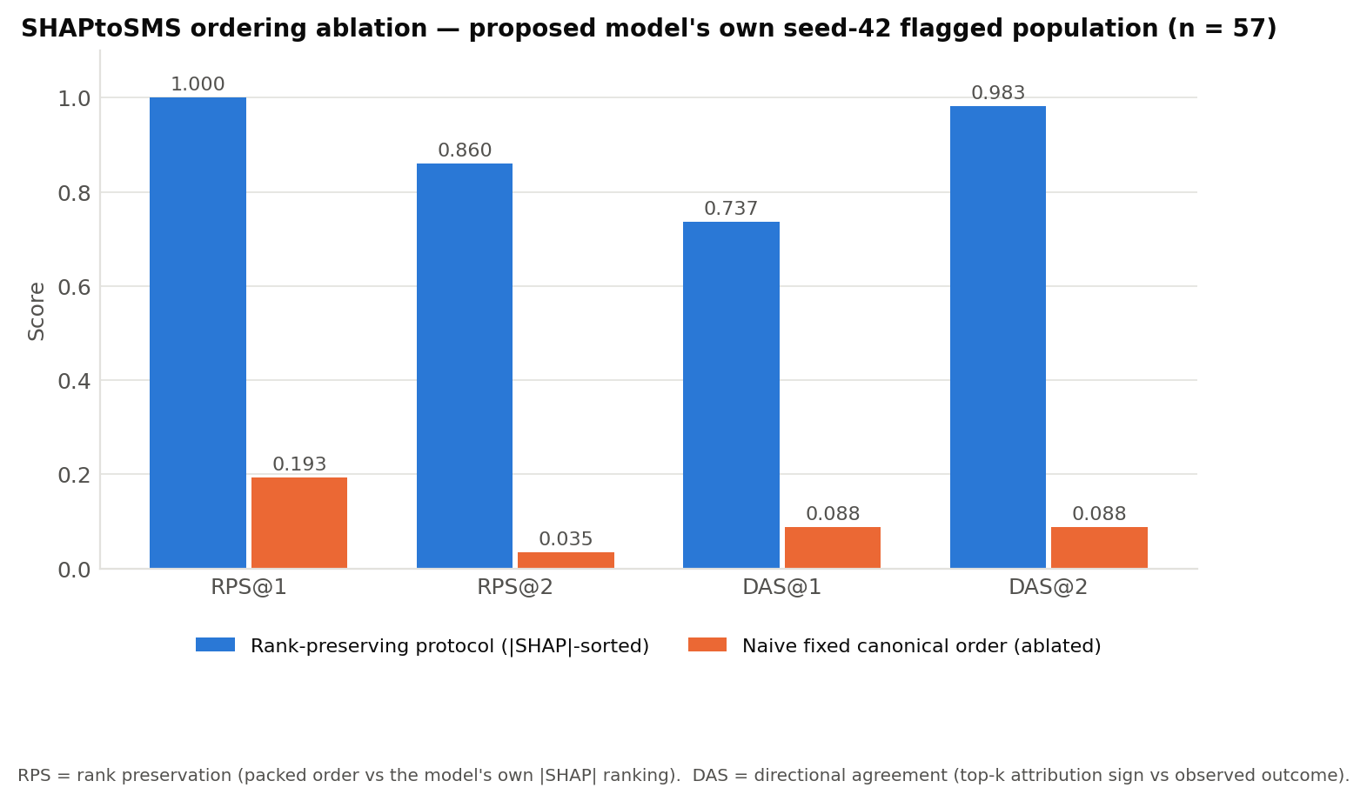
Figure 8. SHAPtoSMS ablation: rank preservation (RPS@1, RPS@2) and directional agreement (DAS@1, DAS@2) for the rank-preserving protocol versus a naive fixed-order baseline, on the proposed model’s own seed-42 flagged population (n = 57).

R6. Feature Importance and Interpretability
SHAP attributions were computed with the exact tree explainer (shap library; Methods M17) over the full 248-row held-out test set. For the proposed model the ordering by mean |SHAP value| was: attendance_rate (1.298), exam_score (1.022), distance_km (0.437), gender_Female (0.322), gender_Male (0.054), fee_payment_status_Fully Paid (0.025), fee_payment_status_Unpaid (0.018), grade_level_Grade 7 (0.000), with the remaining indicators at or near zero. The two native continuous features, attendance_rate and exam_score, ranked first and second. Because the packer appends factors in strict descending order of |φ|, these are the factors an alert leads with whenever they are in the record’s candidate set; the measured rank preservation of RPS@1 = 1.0000 and RPS@2 = 0.8596 (R5) quantifies how often that ordering survives lexicalisation and packing into the delivered alert. Direction is reported alongside magnitude, because mean |SHAP| is unsigned and cannot by itself confirm or contradict a directional expectation. For the top three features the signed attributions were: attendance_rate (mean signed φ = -1.0876, 10.9% of records with positive attribution, correlation between feature value and φ = -0.6934) — higher values are associated with LOWER predicted risk; exam_score (mean signed φ = -0.9696, 6.0% of records with positive attribution, correlation between feature value and φ = -0.1558) — higher values are associated with LOWER predicted risk; distance_km (mean signed φ = -0.3890, 9.7% of records with positive attribution, correlation between feature value and φ = 0.5540) — higher values are associated with HIGHER predicted risk. All three directions agree with the expectations set out in Methods Table 2b: higher attendance and higher examination performance are associated with lower predicted risk, and greater home-to-school distance with higher predicted risk. No top-three feature behaves opposite to its anticipated direction, so the directional check does not trigger the operationalisation-failure or theory-misfit routes, and no theory redirection is indicated. These are associations within the fitted model on one evaluation partition, not causal estimates. Figure 6 reports mean |SHAP value| per feature for the proposed and default XGBoost models, and the signed distributions are given as Supplementary Figure S1. Local SHAP attributions for two illustrative seed-42 cases are provided as Supplementary Figures S2 and S3. Because a single evaluation dataset was used, importance is reported for that dataset and never averaged across datasets.
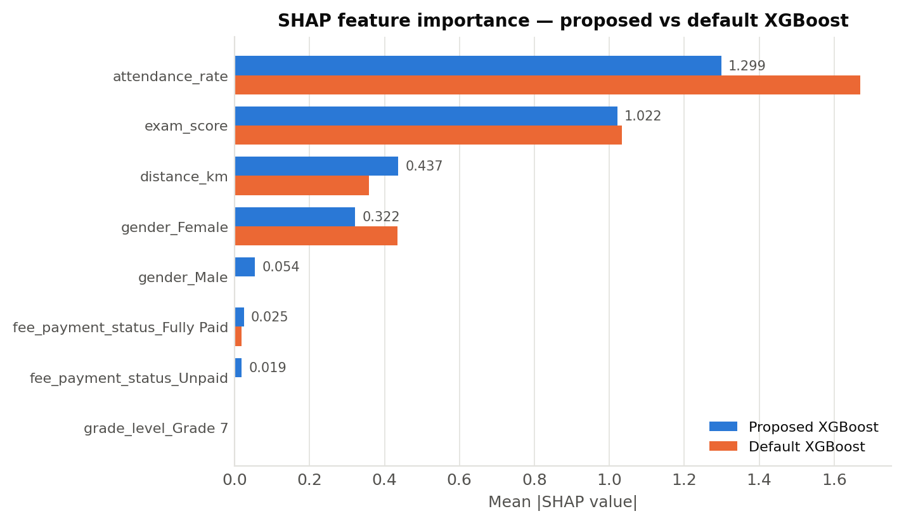
Figure 6. SHAP feature importance (mean |SHAP value|) for the proposed versus default XGBoost, computed on the full held-out test set. Magnitude only; direction is reported in the text and in Supplementary Figure S1.
Table 6. Metric-to-construct translation. Each reported quantity is mapped to the register-observable domain it concerns (Methods Table 2b), the behavioural meaning that follows, and the consequence for the teacher who receives the alert. SDT terms are used as an interpretive lens, not as measurement claims.
Reported quantity | Domain (SDT lens) | Behavioural meaning | Stakeholder consequence
Mean |SHAP| attendance_rate = 1.298 (rank 1) | Relatedness-adjacent (presence) | The presence indicator dominates risk attribution, ahead of performance | Alerts a teacher receives are predominantly about attendance rather than attainment, which shapes which intervention the teacher reaches for first
Mean |SHAP| exam_score = 1.022 (rank 2) | Competence-adjacent (attainment) | Attainment is the second-ranked driver and is named in most alerts | Teachers receive a combined presence-and-attainment picture rather than a single-cause flag
Signed φ direction, attendance and exam score (both negative) | Relatedness- and competence-adjacent | Lower attendance and lower marks are associated with higher predicted risk | The alert’s implied direction of concern matches the direction a teacher would expect, so the message does not invert the signal it carries
Recall = 0.2857 at the seed-42 operating point | Coverage of genuinely at-risk students | 2 of 7 genuinely at-risk students in the test partition are surfaced before disengagement | 5 at-risk students receive no alert at all — the error the system exists to prevent
Precision = 0.0351 at the seed-42 operating point | Cost borne by the teacher | 55 false alarms accompany 2 true cases | Roughly 28 teacher follow-ups are generated per true case surfaced. In a rural JHS with one class teacher per stream, this figure — not AUC-PR — determines whether the system is usable at all
AUC-PR = 0.1167 (primary) | Ranking quality under severe imbalance | 4.1× the prevalence floor of 2.82% | The ranked shortlist is better than random ordering, but not by a margin that supports acting on an individual score without teacher review (R8)

R7. Error Analysis and Per-Class Performance
Figure 7 reports row-normalised confusion matrices at the seed-42 operating thresholds, each row summing to 1.0. At its seed-42 threshold (0.34) the proposed XGBoost flagged 57 of 248 records, giving a true-positive rate (recall) of 0.29 on the minority class (2 of 7 dropout cases) with 5 false negatives, and a false-positive rate of 0.23 (55 false positives of 241 non-dropout records); the corresponding minority-class precision was 0.035. The default XGBoost flagged 54 of 248 records, giving recall 0.29 (2 of 7) with 5 false negatives and a false-positive rate of 0.22 (52 false positives). For reference, TabTransformer at seed 42 recovered 3 of 7 dropout cases (recall 0.43, false-positive rate 0.15). An error analysis across all five seeds identifies which dropout cases the proposed model misses consistently rather than by chance: 3 of the 7 dropout cases (S17_2025, S57_2026, S122_2026) are missed at every one of the five seeds, while 2 (S06_2025, S88_2025) are recovered at every seed. The two groups separate cleanly on the dominant feature: the consistently-missed cases carry scaled attendance of 0.773, 0.639, 0.817, whereas the consistently-recovered cases carry 0.547, 0.516. The students the model consistently misses are therefore those whose attendance and examination values were unremarkable in the snapshot the model sees — the profile a static six-variable representation is structurally unable to separate from the non-dropout majority. Whether year-on-year trajectory features address this profile is examined in R8; under the declared temporal split they are not learnable (Methods M7). No additional systematic error pattern beyond this recall-versus-false-positive trade-off was observed in the confusion counts.
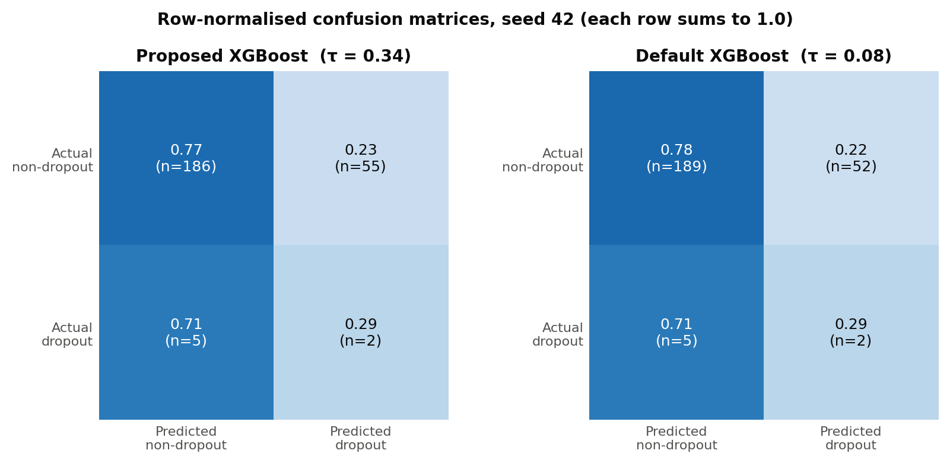
Figure 7. Row-normalised confusion matrices (test set, seed 42) for the proposed and default XGBoost at their respective F2-selected thresholds. Each row sums to 1.0; raw counts are given in parentheses.

R8. Generalisation Results (Tier-1 Substitute Rigour)
Cross-dataset transfer is not applicable under the TRAINING-ONLY AUGMENTATION strategy (Methods M10); a single real evaluation corpus was used and no separate dataset was introduced, so no pooled cross-dataset figure is reported. The Tier-1 substitute-rigour results declared in Methods M18 are reported here. Under 100 Gaussian-noise trials on the three continuous features (attendance_rate ± 0.02, exam_score ± 3.0, distance_km ± 0.5), the mean absolute shift in predicted probability was 0.1265 and the maximum was 0.8758; among the 7 real dropout cases, the maximum number whose predicted class flipped within a single trial was 3 (mean 0.72 per trial), and 7 of 7 flipped at least once across the 100 trials (Supplementary Figure S4). These noise magnitudes are well inside ordinary register and marking error. The resolution boundary this establishes is stated explicitly: individual-level probability estimates are not stable to register-error-scale noise, so the system’s defensible output is a ranked shortlist for teacher review, not a stable individual probability and not an individual motivational diagnosis delivered by name. The student-disjoint sensitivity re-score specified in Methods M9 is not computable on these data and no substitute is reported in its place: all 155 students in the test years also appear in the 2024 training partition, so the disjoint subset contains 0 records and 0 dropout events. New-intake performance is therefore unestimated, and the reported figures are next-year performance for students with prior-year register history. Year-on-year trajectory features (change in attendance_rate, change in exam_score, a prior-year risk flag and a terms-observed count) were engineered from the existing panel and tested, but under the declared 2025 temporal cut the whole training pool falls in academic year 2024 — every student’s first observation — so all four features are identically zero in training and carry variance only at test (Methods M7); they are therefore not learnable under this split, and no improvement is claimed from them. A sensitivity analysis moving the temporal cut to 2026, the only configuration in these data under which prior-year history enters training (627 training records, 66 positive; 151 test records, 3 positive), shows the features do carry signal when learnable: AUC-PR rises from 0.0350 ± 0.0088 to 0.0615 ± 0.0144 and AUC-ROC from 0.6090 to 0.7572, the mean absolute perturbation shift falls from 0.0928 to 0.0803, and one previously always-missed dropout case is recovered at every seed. That arm rests on a test partition containing only 3 dropout events, so it is reported as a direction for the next collection round rather than as a result. Leave-one-year-out cross-validation over the training pool returned no folds, because the entire train+validation pool falls within a single academic year (2024); no leave-one-year-out result is reported for the present data. These checks characterise stability within, not beyond, the studied context.

R9. Computational Cost
Formal latency and throughput benchmarking was not performed, so mean training time per fold, inference time per instance, and peak memory are not reported as measured quantities. As a proxy for offline low-connectivity deployability, and referencing the CPU environment of Methods M19, each TabTransformer seed checkpoint serialised to approximately 1.25 MB and the proposed-XGBoost model to approximately 0.29 MB, both within the sub-10 MB target for storage and USB or district-server transfer. Objective 3, as narrowed in Methods, asks whether a constraint-compliant alert-generation protocol can be specified and verified; Table 5 answers that question and R5 reports the verification. It does not ask whether messages are delivered, and no delivery claim is made here: no message was transmitted, no gateway was contacted and no delivery receipt was measured. Live measurement against a Ghanaian SMS aggregator — reporting delivery receipt rate, billed segment count and median time to delivery receipt — is the identified next-round action and is not evidenced by the present study.

R10. Non-Confirmatory and Negative Results
Several declared comparisons did not favour the proposed model and are reported directly. On the primary metric TabTransformer (AUC-PR 0.2387 ± 0.0559) and the continuous Attendance ranker (0.1284) exceeded the proposed XGBoost (0.1167 ± 0.0444), by 0.1220 and 0.0117 absolute respectively (Table 3). The proposed model did not improve on the default XGBoost on the primary metric: the delta was -0.0302 and its paired bootstrap 95% confidence interval spanned zero ([-0.0409, 0.1227]). Every McNemar comparison ran in the direction of the comparator rather than the proposed model, and two of the four (Decision Tree, TabTransformer) remained significant after Benjamini–Hochberg correction; the direction is stated in Table 4. Isotonic recalibration of the seed-42 proposed model did not improve the primary metric, changing test-set AUC-PR from 0.1033 to 0.0933 (-0.0100); both figures are seed-42 single-run values, so the comparison sits in one reference frame. Its AUC-ROC moved in the opposite direction (0.5969 to 0.6165). Isotonic regression is a monotone non-decreasing transform, so it cannot reorder scores, but it can merge them onto plateaus; because a tied pair scores 0.5 rather than 0 or 1, tying a discordant pair raises AUC-ROC and tying a concordant pair lowers it. A rise is therefore admissible and is not evidence of a scoring error, though it reflects tie creation rather than improved discrimination. Two isolation results run against the study’s own design choices: the configured SMOTE sampling_strategy of 0.20 is not the best available setting (0.50 gives AUC-PR 0.1343 against 0.1167), and applying scale_pos_weight on top of an F2-optimised threshold does not improve on the threshold alone (0.1167 against 0.1302 at scale_pos_weight = 1), so the three-layer imbalance pipeline is not uniformly load-bearing and Layer 2 in particular is not doing the work attributed to it. The synthetic-data audit recorded a Nearest-Neighbour Adversarial Accuracy of 0.664 for the CTGAN supplement, above the 0.60 ceiling adopted in Methods M4, and the retained within-training SMOTE configuration (k = 3, sampling_strategy = 0.20) recorded a Nearest-Neighbour Adversarial Accuracy of 0.9118 at seed 42 (0.8996 ± 0.0084 across the five seeds), which also exceeds that same ceiling — as does every other rung of the escalation ladder (0.9181 at k = 5, 0.8991 at k = 1, 0.9706 for the DP-SMOTE variant), so the ladder does not remedy the breach. Both breaches are reported here, because an earlier draft disclosed the supplement figure alone and applied the ceiling inconsistently across the two synthesis stages. One qualification belongs with the SMOTE figure and is stated rather than left for a reader to derive: its audit set holds 450 real rows against 26 synthesised rows, so a majority-class classifier scores 0.9454 and the plain-SMOTE rungs fall below that baseline, which indicates the statistic is dominated by the composition of the audit set rather than by memorisation of real records (M8). 2 of 350 synthetic rows fell within 1×10⁻³ of a real record. All 7 of the 7 dropout cases flipped class at least once under perturbation, up to 3 within a single trial. Year-on-year trajectory features are not learnable under the declared temporal split (R8). The student-disjoint sensitivity re-score is not computable on these data (R8). Objective 3 evidences generation-side constraint compliance only; no message was delivered or measured (R9).

Supplementary Material
The following items are supplementary to the main Results (which contains eight items: Tables 3–5 and Figures 4–8) and are pointed to from R6 and R8.
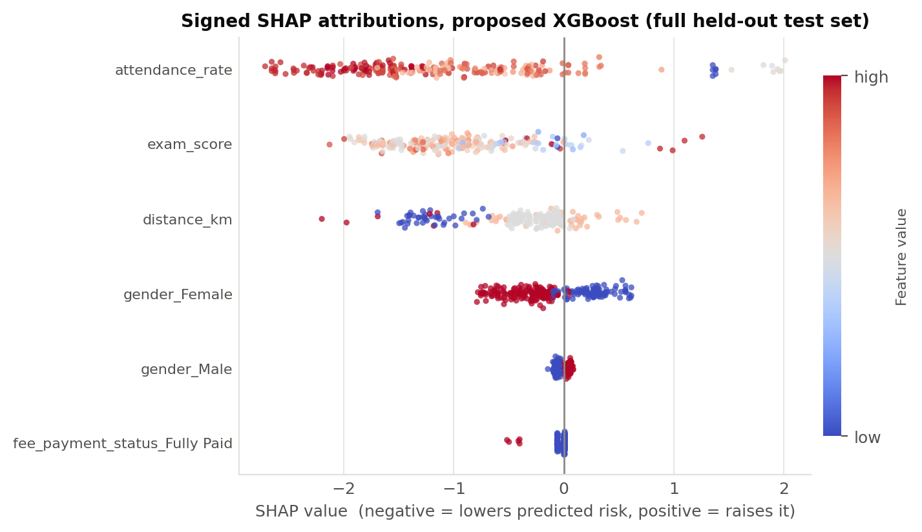
Figure S1. Signed SHAP attributions for the six highest-attribution features, proposed XGBoost, full held-out test set. Each point is one record; horizontal position is the signed SHAP value (negative lowers predicted risk, positive raises it) and colour is the feature value. This is the directional evidence for R6.
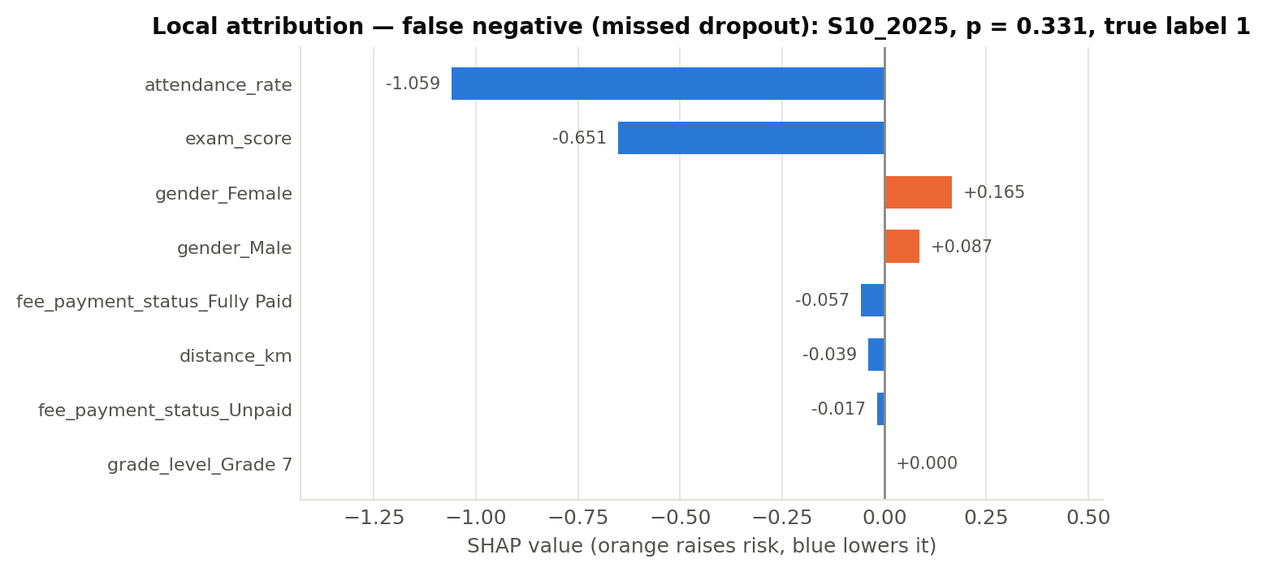
Figure S2. Local SHAP attribution — false-negative (missed dropout) case at seed 42 (student S10_2025, predicted probability 0.331, true label 1).
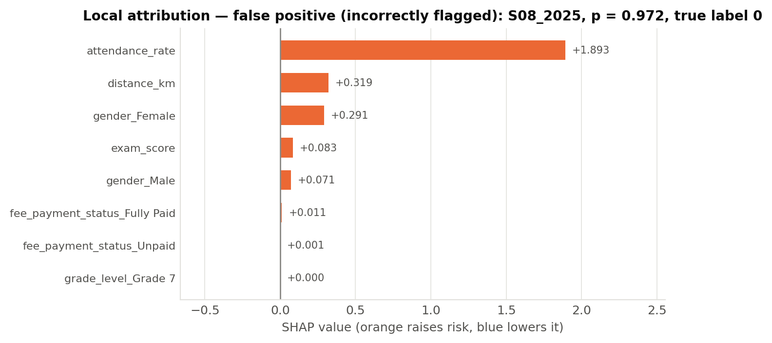
Figure S3. Local SHAP attribution — false-positive (incorrectly flagged) case at seed 42 (student S08_2025, predicted probability 0.972, true label 0).
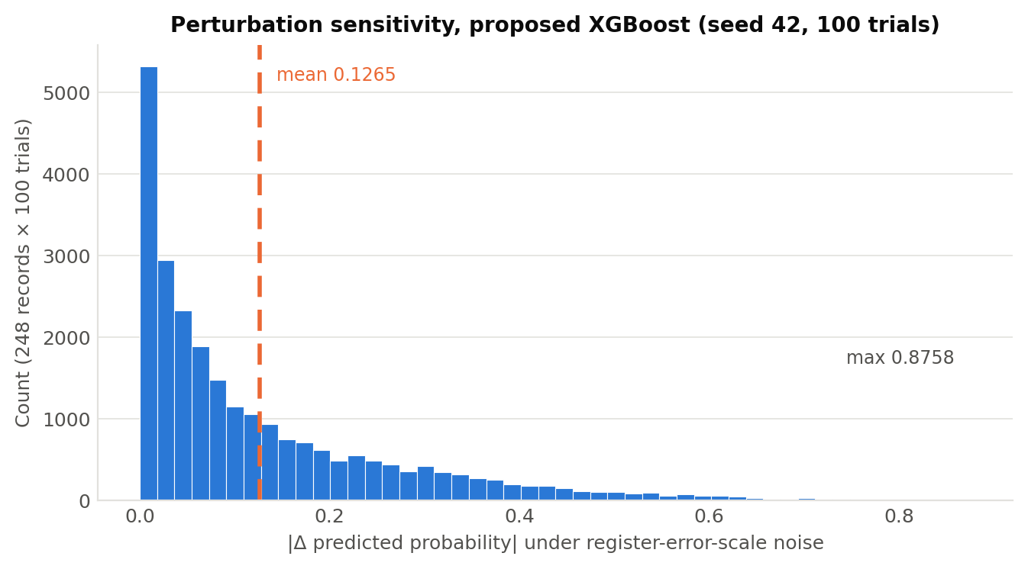
Figure S4. Perturbation analysis — distribution of |Δ predicted probability| across 100 trials on the 248 test records; the dashed line marks the mean (0.1265), and the maximum observed shift was 0.8758.

R11. Number Reconciliation
Every quantity reported in this section traces to the single locked run described in Methods M21 — the committed pipeline, the seed-42 synthetic supplement committed as a data artefact, and the consolidated results file. Table 7 reconciles each headline figure as it appears in the narrative text, in the tables, and in the figures, so that the three agree by inspection rather than by assertion. Figures reported in an earlier draft that did not reconcile to a retained artefact have been recomputed from this run and are not carried forward.
Quantity | In text | In table / figure | Source in the locked run
Test partition size | 248 records, 7 dropout (R1) | Table 3 caption; Table 4 basis | Temporal split, academic_year ≥ 2025
Train+validation pool | 530 records, 62 positive, 11.7% (R1) | Methods Table 1b | Pooled 2024 real + seeded CTGAN supplement
Proposed AUC-PR (5 seeds) | 0.1167 ± 0.0444 (R2) | Table 3 row 1 | Five-seed mean over {42, 123, 777, 2024, 9999}
Proposed AUC-PR (seed 42) | 0.1033 (R10) | Table 3 footnote ¶ | Seed-42 single run; anchor for the isotonic comparison
Proposed vs default Δ AUC-PR | -0.0302 (R2, R5, R10) | Table 3 Δ column | Five-seed means, both models
Bootstrap 95% CI | [-0.0409, 0.1227] (R2, R4, R10) | — | Paired bootstrap, 10,000 resamples, seed-42 predictions
Attendance — threshold-free | AUC-ROC 0.8678, AUC-PR 0.1284 (R2) | Table 3, ranker row § | Score vector 1 − scaled(attendance_rate)
Attendance — operating point | precision 0.0893, recall 0.7143, F2 0.2976 (R2) | Table 3, binary rule row ‡ | attendance_rate < 0.70; TP 5, FP 51, FN 2
Attendance — single-point areas | AUC-ROC 0.7513 (R2) | Table 3 footnote ‡ | (1 + TPR − FPR)/2 at TPR 0.7143, FPR 0.2116
McNemar directions | All four favour the comparator (R4, R10) | Table 4 Direction column | Seed-42 paired predictions, BH-corrected
Rank preservation (RPS@1) | 1.0000 vs naive 0.1930 (R5) | Figure 8 | Proposed model's own seed-42 flagged population, n = 57
Directional agreement (DAS@1) | 0.7368 vs naive 0.0877 (R5) | Figure 8 | Same population; separately named per Methods M17
Alert compliance | 57/57, 70–155 chars (R5) | Table 5 | SHAPtoSMS implementation of Algorithm 1
Top SHAP features | attendance_rate 1.298, exam_score 1.022, distance_km 0.437 (R6) | Figure 6; Table 6 | TreeExplainer over the full 248-row test set
Signed directions | All three agree with Methods Table 2b (R6) | Figure S1 | Signed SHAP, same explainer run
Perturbation | mean |Δp| 0.1265, max 0.8758, up to 3 of 7 flipping (R8, R10) | Figure S4 | 100 Gaussian trials, seed-42 model
Cross-validation | proposed 0.214 ± 0.077 (R3) | Figure 5 | Stratified 5-fold on the train+validation pool
Student-disjoint subset | 0 records — not computable (R8) | Methods Table 1b | Student identifiers across the temporal split
Lag features | Not learnable under the declared split (R7, R8) | Methods M7 | Zero training variance (SD = 0.000000 on all four)
SMOTE NNAA (retained k = 3) | 0.9118 at seed 42, 0.8996 ± 0.0084 across seeds (R10) | Methods M8 | 1-NN adversary on the post-split training partition; 450 real : 26 synthesised
Layer 2 isolation (2 × 2) | AUC-PR 0.1167 / 0.1302; recall 0.4000 / 0.4286 / 0.3143 / 0.2286 (R5) | Methods M16 declares both arms | Five-seed means; scale_pos_weight {1, 7.49} × threshold {F2, 0.5}

